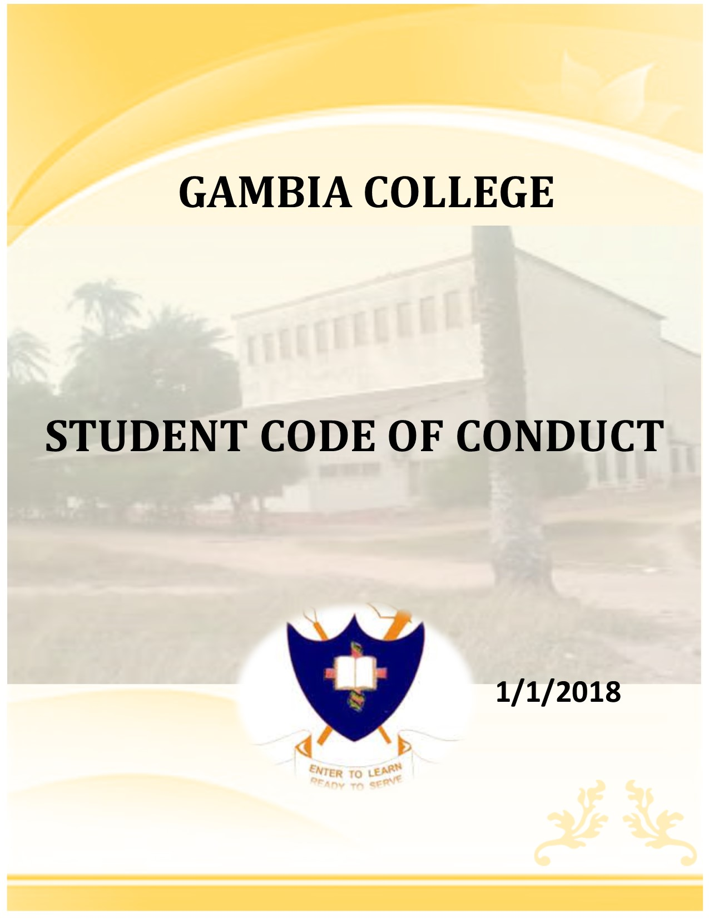

|  |
| --- |
| **GAMBIA COLLEGE** |
| **STUDENT CODE OF CONDUCT** |
|  |
| **1/1/2018** |

Contents

Preamble 4

Conduct expectations 4

Definitions 4

Student code of conduct authority 6

Proscribed conduct 6

Jurisdiction of the College’s Student Code of Conduct 6

Student Code of Conduct - Core Values and Behavioral Expectations 7

Integrity 7

Community 8

Social Justice 9

Respect 10

Responsibility 11

Marriage life, family life 12

Violation of Law and College Discipline 12

Sanctions 13

Burden of Proof 14

Interim Suspension 14

Appeals 15

Student Conduct Records 15

Interpretation and Revisions 15

# 

# Preamble

Gambia College stands for the human dignity and worth of every person.  Members of the campus community must act out of mutual respect to establish an atmosphere of trust.  We believe in values that foster the human respect for people to live, work, study and recreate together as a community.   Enrollment in Gambia College presumes an obligation on the part of the student to act at all times in a manner compatible with the College's purpose, processes and functions. Students are expected to uphold standards of personal and academic integrity and behavior. Further, students are expected to respect the rights and privileges of all members of the Gambia College community.  If the behavior or conduct of a student infringes on other members of the community or negatively impacts the institution, Gambia College reserves the right to address the behavior through the student conduct process outlined in this document.

The College, through the Student Union and under the authority of the Vice President of Student Union, has established the Student Code of Conduct. Each student is required to abide by this code. The Student Code of Conduct is designed to assist in building an integrated, vibrant community that fosters the personal development of every Gambia College student.

# Conduct expectations

Students are expected to act responsibly and to avoid conduct detrimental in its effect upon themselves, their fellow students and the College, both on-and-off-campuses. Students are expected to know and abide by all College rules, regulations, policies and standards. Students are expected to uphold both the mission of the College and the Student Code of Conduct in action and deed while they attend Gambia College. Ignorance of College rules and regulations will not be considered as an excuse for violations.

Students should be aware that the student conduct process is quite different from criminal and civil court proceedings. Procedures and rights in student conduct procedures are conducted with fairness to all, but do not include the same protections of due process afforded by the courts. Due process, as defined within these procedures, assures written notice and a conduct meeting with a student union representative before an objective decision-maker. No student will be found in violation of College policy without information showing that it is more likely than not that a policy violation occurred and any sanctions will be proportionate to the severity of the violation and to the cumulative conduct history of the student.

# Definitions

1. The term “College” means Gambia College
2. The term “student” includes all persons officially taking courses at the College, either full-time or part-time, pursuing certificate, diploma, Advance/ Higher Diploma, professional courses or extramural classes.  Persons who suspects after allegedly violating certain student code of conduct
3. Who are not officially enrolled for a particular term but who have a continuous official relationship with the College or who have been notified of their acceptance for admissions are considered “students”. as are persons who are living in the College Dormitories, although not enrolled in Gambia College.  The Student Code of Conduct applies at all locations of the College, including the all sites in which the College conducts classes.  It also applies to student on attachment or posting.
4. The term “lecturer/tutors” means any person hired by the College to conduct classroom or teaching activities or who is otherwise considered by the College to be a member of its schools.
5. The term “College official” includes any person employed by the College, performing assigned administrative or professional responsibilities.
6. The term “member of the College community” includes any person who is a student, lecturer/tutor, staff member or any other person employed by the College.  A person’s status in a particular situation shall be determined by the Principal ……………………. or his or her designee.
7. The term “College premises” includes all land, buildings, facilities, and other property in the possession of or owned, used, leased, or controlled by the College, including adjacent streets and sidewalks.
8. The term “organization” means any number of persons who have complied with the requirements for College recognition.
9. The term “Student Conduct Board” means any person or persons authorized by the Principal, or his or her designee,  to determine whether a student has violated the Student Code of Conduct and to recommend sanctions that may be imposed when a rules violations has been committed.
10. The term ”Student Conduct Officer” means a College official authorized by the …Principal……………………………, or his or her designee, to impose sanctions upon any student(s) found to have violated the Student Code of Conduct.
11. The term “shall” is used in the imperative sense
12. The term “may” is used in the permissive sense.
13. The …principal………………….., or his or her designee, is that person designated by the College to be responsible for the administration of the Student Code of Conduct.
14. The term “policy” means the written regulations of the College as found in, but not limited to, the Student Code of Conduct
15. The term “cheating” includes, but is not limited to: (1) use of any unauthorized assistance in taking tests, quizzes, or exams; (2) use of sources beyond those authorized by the lecturer in writing papers, preparing reports,  solving problems or carrying out other assignments; (3) the acquisition, without permission, of tests or other academic material belong to a member of the College schools or staff; (4) engaging in any behavior specifically prohibited by a lecture in the course syllabus or class discussion.
16. The term “plagiarism” includes, but is not limited to, the use, by paraphrase or direct quotation, of the published or unpublished work of another person without full and clear acknowledgement.  It also includes the unacknowledged use of materials prepared by another person or agency engaged in the selling of term papers or other academic materials.
17. The term “reporting party” means any person who submits an allegation that a student violated the Student Code of Conduct.
18. The term “responding party” means any student who has allegedly violated the Student Code of Conduct.

# Student code of conduct authority

The Principal…………………. or his or her designee in collaboration with the students' union, shall develop policies for the administration of the student conduct system and procedural rules for the Student Conduct Board hearings that are consistent with the provisions of the Student Code of Conduct.  Decisions made by a Student Conduct Board and/or Student Conduct Administrator shall be final, pending the normal appeals process.  Once an appeal has been presented, and a decision rendered in said appeal, that decision is final.

# Proscribed conduct

## Jurisdiction of the College’s Student Code of Conduct

The College, through the Principal or his or her designee in collaboration with the students' union………………………., has established the Student Code of Conduct.  Each student is required to abide by this code.  The Code is designed to assist in building an integrated, vibrant community that fosters the personal development of every Gambia College student.  As a member of the Gambia College’s community, it is your responsibility to be familiar with the Student Code of Conduct and the College policies and procedures included in the Student Handbook.

The College’s Student Code of Conduct shall apply to conduct that occurs on College premises, at College sponsored activities, and to off-campus conduct that adversely affects the College community and/or the pursuit of its objectives.  Each student shall be responsible for his/her conduct from the time of application for admissions through the actual awarding of a degree,

even though conduct may occur before classes begin or after classes end, as well as during the academic year and during periods between terms of actual enrollment (and even if their conduct is not discovered until after a degree is awarded).  The Student Code of Conduct shall apply to a student’s conduct even if the student withdraws from school while a disciplinary matter is pending.  The Vice President of Students' union, or his or her designee, shall decide whether the Student Code of Conduct shall be applied to conduct occurring off campus, on a case by case basis, in his/her sole discretion

## Student Code of Conduct - Core Values and Behavioral Expectations

The College considers the behavior described in the following sub-sections as inappropriate for the College community and in opposition to the core values set forth in this document. These expectation and rules apply to all students.,. The College encourages community members to report to College officials all incidents that involve the following actions.  Any student found to have committed or to have attempted to commit the following misconduct is subject to the sanctions outlined in Conduct Procedures.

### Integrity

**College students exemplify honesty, honor and a respect for the truth in all their dealings. Behavior that violates this value includes, but is not limited to:**

* 1. **Conduct unbecoming of a Gambia College Student**.  Enrollment in Gambia College presumes an obligation on the part of the student to act at all times in a manner compatible with the College's mission, core commitments and functions. Students are expected to uphold standards of personal and academic integrity and behavior. Further, students are expected to respect the rights and privileges of all members of the Gambia College community.
  2. **Falsification**.  Knowingly furnishing or possessing false, falsified or forged materials, documents, accounts, records, identification or financial instruments;
  3. **Academic dishonesty**.  Acts of academic dishonesty as outlined in the Academic Dishonesty Policy found in the Student Handbook and the College Catalogue(s).
  4. **Unauthorized access**.  Unauthorized access to any College building (i.e., keys, cards, etc.) or unauthorized possession, duplication or use of means of access to any College building or failing to timely report a lost College identification card or key;
  5. **Collusion.**  Action or inaction with another or others to violate the Student Code of Conduct;
  6. **Trust.**  Violations of positions of trust within the community;
  7. **Election Tampering- Students’ election**.  Tampering with the election of any College recognized student organization (minor election code violations are addressed by the Students' Union;
  8. **Theft**.  Intentional and unauthorized taking of College property or the personal property of another, including goods, services and other valuables;
  9. **Stolen Property**.  Knowingly taking or maintaining possession of stolen property.

### Community

**College students build and enhance their community. Behavior that violates this value includes, but is not limited to:**

* 1. **Disruptive Behavior**.  Disruption of College operations including obstruction of teaching, research, administration, other College activities, and/or other authorized non-College activities which occur on- or off campus;
  2. **Rioting**.  Causing, inciting or participating in any disturbance that presents a clear and present danger to self or others, causes physical harm to others, or damage and/or destruction of property;
  3. **Unauthorized Entry**. Misuse of access privileges to College premises or unauthorized entry to or use of buildings, including trespassing, propping or unauthorized use of alarmed doors for entry into or exit from a College building;
  4. **Trademark Violation**. Unauthorized use (including misuse) of College or organizational names and images;
  5. **Damage and Destruction**. Intentional, reckless and/or unauthorized damage to or destruction of College property or the personal property of another( including, doors, switches, toilets, rails, chairs, tables etc);
  6. **Littering**. Intentional littering, throwing of papers, remains from food, in the classrooms, outside the classrooms, behind the dormitories or anywhere within the college campus
  7. **IT and Acceptable Use**. Violating the College’s Computer Use Policy.
  8. **Gambling**. Gambling as prohibited by the laws of the Gambia College. Gambling may include raffles, lotteries, sports pools and online betting activities.
  9. **Weapons**. Possession, use, or distribution of dangerous objects such as, axes, machetes, or knives with a blade of longer than four (4) inches, including the storage of any item that falls within the category of a weapon in the classroom or dormitories;
  10. **Substance abuse**. Gambia College is a smoke and substance abuse-free campus.  Use of all forms of tobacco and other substances(illicit drugs) is prohibited in any space owned or leased by the College;
  11. **Fire Safety**. Intentionally or recklessly causing a fire which damages College or personal property or which causes injury;
  12. **Ineligible Pledging or Association**. Pledging or associating with a student organization without having met eligibility requirements established by the College;
  13. **Animals**. Animals, with the exception of college owned are not permitted on campus.
  14. **Wheeled Devices**. Scooters, Motorbikes, bicycles and similar wheeled devices are not permitted inside College buildings, verandas, dormitories and/or tennis/basketball courts.
  15. **Violation of dormitory policies** (refer to the dormitory policy)

### Social Justice

Students recognize that respecting the dignity of every person is essential for creating and sustaining a flourishing College community. They understand and appreciate how their decisions and actions impact others and are just and equitable in their treatment of all members of the community. They act to discourage and challenge those whose action may be harmful to and/or diminish the worth of others. Conduct that violates this value includes, but is not limited to:

* 1. **Discrimination**. Any act or failure to act that is based upon an individual or group’s actual or perceived status (race, creed, color, ethnicity, national origin, ancestry, religion, gender, sexual orientation, gender identity, genetic information, familial status, marital status, pregnancy, age, disability status, or veteran status) that is sufficiently severe that it limits or denies the ability to participate in or benefit from the College’s educational program or activities;
  2. **Harassment**. Any unwelcome and/or unsolicited conduct based on actual or perceived status including: race, creed, color, ethnicity, national origin, ancestry, religion, gender, sexual orientation, gender identity, genetic information, familial status, marital status, pregnancy, age, disability status, or veteran status or other protected status. Any unwelcome conduct should be reported to campus officials, who will act to remedy and resolve reported incidents on behalf of the victim and community. **Hostile Environment**. Sanctions can and will be imposed for the creation of a hostile environment only when (unwelcome) harassment is sufficiently severe, pervasive (or persistent) and objectively offensive that it unreasonably interferes with, limits or denies the ability to participate in or benefit from the College’s educational or employment program or activities;
  3. **Retaliatory Discrimination or Harassment**. Any intentional, adverse action taken by an responding individual or allied third party, absent legitimate nondiscriminatory purposes, against a participant (or supporter of a participant) in a civil rights grievance proceeding or other protected activity under this Code;
  4. **By-standing**.
     1. Complicity with or failure of any student to appropriately address known or obvious violations of the Student code of conduct*;*
     2. Complicity with or failure of any organized group to appropriately address known or obvious violations of the Student code of conduct its members;
  5. **Abuse of Conduct Process**. Abuse or interference with, or failure to comply with, College processes, including conduct and academic integrity meetings/hearings, including, but not limited to:
     1. Falsification, distortion, or misrepresentation of information;
     2. Failure to provide, or destroying or concealing information during an investigation of an alleged policy violation;
     3. Attempting to discourage an individual’s proper participation in, or use of, the campus conduct system;
     4. Harassment (verbal or physical) and/or intimidation of a member of a campus conduct body prior to, during, and/or following a campus conduct proceeding;
     5. Failure to comply with the sanction(s) imposed by the campus conduct system;
     6. Influencing, or attempting to influence, another person to commit an abuse of the campus conduct system.

### Respect

**College students show positive regard for one self and each other and for the community. Behavior that violates this value includes, but is not limited to:**

* 1. **Harm to Persons**. Intentionally or recklessly causing physical harm or endangering the health or safety of any person;
  2. **Threatening Behaviors**:
     1. Threat. Written or verbal conduct that causes a reasonable expectation of injury to the health or safety of any person or damage to any property.
     2. Intimidation. Intimidation defined as implied threats or acts that cause a reasonable fear of harm in another;
  3. **Bullying**. Bullying is severe aggressive behavior that intimidate or intentionally harm or control another person physically or emotionally, and are not protected by freedom of expression;
  4. **Intimate Partner/Relationship Violence**. Violence or abuse by a person in an intimate relationship with another;
  5. **Stalking**. Stalking is repetitive and menacing pursuit, following, harassing and/or interfering with the peace and safety of a specific person that is unwelcome and would cause a reasonable person to feel fear;
  6. **Sexual Misconduct**. Includes, but is not limited to, sexual harassment, non-consensual sexual contact, non-consensual sexual intercourse, and/or sexual exploitation;
  7. **Public Exposure**. Includes deliberately and publicly exposing one’s intimate body parts, public urination, defecation, and public sex acts.

### Responsibility

**College students are given and accept a high level of responsibility to self, to others and to the community. Behavior that violates this value includes, but is not limited to:**

* 1. **Drugs and Marijuana**. Use, possession or distribution of illegal drugs and other controlled substances or Marijuana and the use or display of such in public areas in the dormitories and all other public areas of the campus ;
  2. **Alcohol**. Use, possession, or distribution of alcoholic beverages also, public intoxication or public displays of alcoholic beverages and the use or display of such in public areas in the dormitories and all other public areas of the campus;
  3. **Failure to Comply**. Failure to comply with the reasonable directives of College officials (this includes Resident tutor) security officer during the performance of their duties and/or failure to identify oneself to these persons when requested to do so;
  4. **Financial Responsibilities**. Failure to promptly meet financial responsibilities to the institution, including, but not limited to; knowingly passing a worthless check or money order in payment to the institution or to an official of the institution acting in an official capacity;

### 

### Marriage life, family life

**College students are given and accepts a high responsibility of balancing college life with family life**

* 1. **Marriage**. Being married or having a family is not an excuse for failing to attend classes regularly and on time, submit assignments, take tests or exams
  2. **Pregnancy**: Pregnancy is not a medical condition, therefore failing to attend classes regularly and on time, submit assignments, take tests or exams. It shall be noted that no female student shall be terminated or suspended due to pregnancy.
  3. **Breastfeeding:**

# Violation of Law and College Discipline

* 1. College student conduct proceedings may be instituted against a student who is alleged to be responsible for conduct that potentially violates both the criminal law and the Student Code of Conduct (that is, if both possible violations result from the same factual situation) without regard to the pendency of civil or criminal litigation in court or criminal arrest and prosecution.  Proceedings under the Student Code of Conduct may be carried out prior to, simultaneously with, or following civil or criminal proceedings off-campus at the discretion of the Registry.  Determinations made or sanctions imposed, under the Student Code of Conduct shall not be subject to change because criminal charges arising out of the same facts giving rise to violation of College rules were dismissed, reduced, or resolved in favor of or against the criminal law defendant.
  2. When a student is charged by law, with a violation of law, the College will not request, or agree to, special consideration for that individual because of his or her status as a student.  If the alleged offense is also being processed under the Student Code of Conduct, the College may advise off-campus authorities of the existence of the Student Code of Conduct and of how such matters are typically handled within the College community.  The College will attempt to cooperate with law enforcement and other agencies in the enforcement of criminal law on campus and in the conditions imposed by criminal courts for the rehabilitation of student violators (provided that the conditions do not conflict with campus rules or sanctions).  Individual students and other members of the College community, acting in their personal capacities, remain free to interact with governmental representatives as they deem appropriate.

## 

## Sanctions

The Student Conduct Officer holding an Administrative Hearing and/or the Student Conduct Board are authorized to impose the following sanctions:

* + 1. Warning – a notice in writing that the student has violated institutional regulations.
    2. Redress (apology, either written or oral)
    3. Restitution – compensation for loss, damage or injury.  This may take the form of appropriate service and/or monetary or material replacement.
    4. Fine
    5. Loss of privileges – denial of specified privileges for a designated period of time, including, but not limited to, restrictions from and/or limited access to specified areas of campus and/or College events.
    6. Behavioral Agreement – a set of appropriate actions imposed to provide an educational experience as well as conduct guidelines for an extended period.
    7. Housing Probation – A written reprimand indicating that the student’s behavior has raised serious questions concerning the student’s status as a member of the College dormitory.   The student will be given a stated period during which his/her conduct will establish whether s/he is to be returned to good standing by having met definite requirements in behavior or whether s/he is to be suspended or expelled from the College.  This sanction includes the probability of more severe sanctions if the student is found to violate any College regulation(s) during the probationary period.
    8. Housing Termination – this may be for a definite period of time, after which the student is eligible to return or permanent separation from College dormitory.
    9. College Probation – A written reprimand indicating that the student’s behavior has raised serious questions concerning the student’s status as a member of the College community.  The student will be given a stated period during which his/her conduct will establish whether s/he is to be returned to good standing by having met definite requirements in behavior or whether s/he is to be suspended or expelled from the College.  This sanction includes the probability of more severe sanctions if the student is found to violate any College regulation(s) during the probationary period.
    10. Students may not represent the College or hold office in any student organization during the period of probation.
    11. College Suspension – separation of the student from the College for a definite period of time, after which the student is eligible to return.  Readmission, however, is not automatic and is at the sole discretion of the College.  Conditions for readmission must be specified.  The student is not allowed to be on campus, any College owned or leased property, or attend any College event, on or off campus while on College suspension.
    12. College Expulsion – permanent separation of the student from the College.  The student is not allowed to be on campus, any College owned or leased property, or attend any College event, on or off campus.
    13. Revocation of Admission and/or Certificate – Admission to, or a programme awarded from, the College may be revoked for fraud, misrepresentation, or other violation of College standards in obtaining the Certificate, or for other serious violations committed by a student prior to graduation.
    14. More than one of the sanctions listed above may be imposed for any single violation.

# Burden of Proof

Determination of responsibility in any student conduct meeting/hearing shall be made on the basis of whether it is more likely than not that the Responding Party violated the Student Code of Conduct or any other College policy.

# Interim Suspension

In certain circumstances, the Registry, or his or her designee, may impose a College suspension prior to any Student Conduct Hearing.

* + 1. Interim Suspension may be imposed on a student only:  1) to insure the safety and well-being of members of the College community or preservation of College property; 2) to ensure the student’s own physical or emotional safety and well-being; or, 3) if the student poses an ongoing threat of disruption of, or interference with, the normal operations of the College.
    2. While on Interim Suspension, a student will not be allowed access to the campus, including all College owned or leased properties, including the residence halls and/or all College activities, on or off campus, or privileges as the Registry may determine to be appropriate.
    3. Interim Suspension does not replace the regular Student Conduct process.  At the time a student is interim suspended, the individual affected shall be informed of a right to a conduct meeting without undue delay. The student shall remain dismissed until his/her status is determined in a conduct meeting.

# 

# Appeals

Only cases which result in loss of College housing, suspension and/or expulsion may be appealed.

A decision reached, and/or sanction imposed, by a Student Conduct Administrator or a Student Conduct Board, may be appealed by the Responding Party, in writing, within forty-eight (48) hours (not including weekend and/or holidays) of the decision.

The administrators authorized to hear appeals are:  the Resident tutor, , the registry and, the Vice President for Student Union.  The Vice President for Student Union is the highest level of appeal in the College.

Appeals, regardless of the type of adjudication, shall be based only on:

* + 1. Questions of improper procedure and/or
    2. Information not available at the time of conduct meeting and/or
    3. Appropriateness of sanctions

The response to the appeal shall be sent to the responding party within forty-eight (48) to seventy-two (72) hours (not including weekend and/or holidays) of receipt.

Decisions of the Student Conduct Board and/or Student Conduct Administrator remain in effect until such time, if and when, an appeal is granted. All parties involved will be informed of the disposition of appeals.

Once an appeal has been heard, the decision issued regarding that appeal is final.

# Student Conduct Records

Other than expulsion from the College, conduct sanctions shall not be made part of the student’s permanent academic record (transcript). They will, however, become part of the student’s conduct record which is in turn part of a student’s education records. This applies both to the Reporting Party and the Responding Party.

# Interpretation and Revisions

Any questions of interpretation or application of the Student Code of Conduct shall be referred to the Principal……………………, or his or her designee, for final determination.

The Student Code of Conduct shall be reviewed every three year sunder the direction of the Principal and collaboration with the Students' union……………………………...

Should include dress code for students