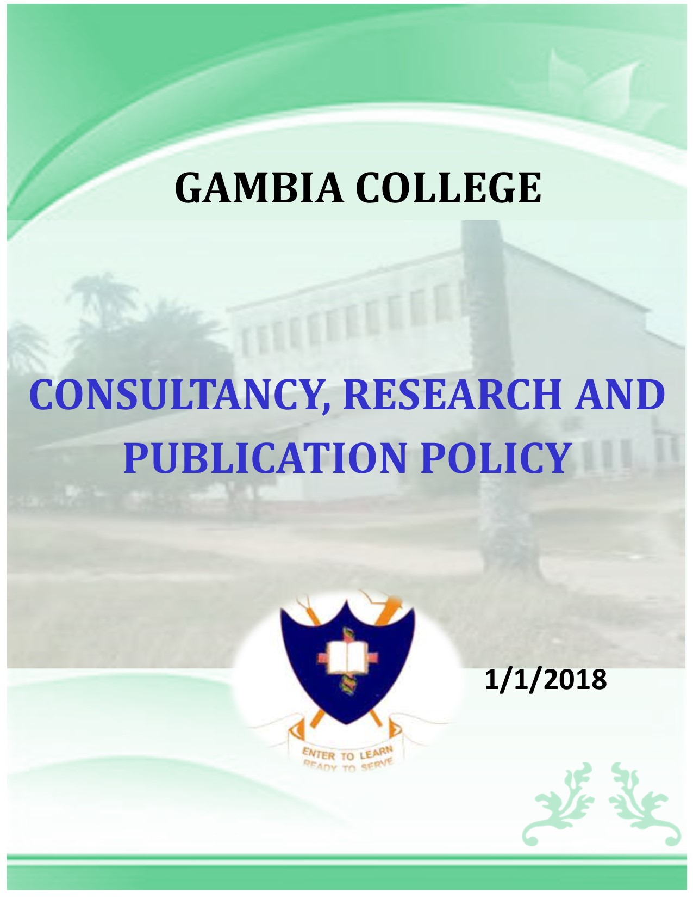

|  |
| --- |
| GAMBIA COLLEGE |
| CONSULTANCY, RESEARCH AND PUBLICATION POLICY |
|  |
|  |
| **GAMBIA COLLEGE** |
| **1/1/2018** |

Contents

Introduction 4

Definitions 4

Application 5

College Supported Consultancy 5

Payment for college supported consultancy 6

Private consultancy 6

Publication 7

Journals 7

Occasional Publications 8

RESEARCH 8

OBJECTIVES OF THE RESEARCH POLICY 8

Overall Objective 8

Specific Objectives 8

Research priority 8

Research Funding 9

The Gambia College Research Committee 10

Composition of the Gambia College Research Committee 10

Terms of Reference for the Gambia College Research Committee 10

Mandate of the Directorate of Research and Development 10

Research in the Gambia College 12

Approval, Monitoring and Control of Research Projects 12

Contribution to Research Administration Costs 13

Sharing/disposal of Research Project Resources 13

Remuneration of Research Staff 14

Creating a Conducive Research Environment 14

Dissemination of Research Results 15

Ownership of Research Outputs 16

Monitoring of Research impact 16

Ethical, Environmental and Security Considerations 16

Conclusion 16

# Introduction

The purpose of this Policy is to set out the principles and guidelines for governing Consultancy, Research and Publication and other outside services undertaken by Staff Members of College.

Staff Members of the Gambia College are encouraged to undertake College Supported Consultancy, Research and other similar work provided it does not conflict with the interests of the College. This is because these activities:

* increase the professional and/or academic competence and experience of the Staff Member and provides a continuing professional education opportunity in the world outside academia;
* creates and enhances links between the Gambia College and external organisations that will aid the Gambia College in areas such as increasing research opportunities, and student recruitment and placement, and helps the college achieve its mission of knowledge transfer to improve the local and regional economies; and
* May generate additional income for the Staff Member and increased funding for the Gambia College.

This Policy applies to all academic and academic related Staff Members and administrative Staff Members at a grade 4 or above.

# Definitions

**College** means The Gambia College

**Principal** means the Head of the College

**Vice Principal** means the immediate assistant of the Principal

**Registrar** means the Head of Administrative Staff of the College

**Deputy Registrar:** means the immediate assistant of the Registrar

**Head of School** means the Head of the component Schools of The Gambia College

**Chief Finance Officer** means the Financial Controller of the College

**Senior Lecturer** means lecturer on Grade 6 and above of the College

**Lecturer** means lecturer on Grade 5 of the College

**Policy** means this Policy on Research, Consultancy and Publication

**Consultancy** means the general application of existing Skills, Knowledge and Expertise and includes teaching commitments undertaken outside the College Consultancy is a work of a professional nature, undertaken by college staff in their field of expertise, for external clients, for which payment is usually made.  It increases the professional and/or academic competence and experience of the senior members of College and provides a continuing professional education opportunity in the world outside the confines of the College.

The Consultancy can generate additional income for the Staff Member and increased funding for the College. Senior members of the College are encouraged to undertake College Supported Consultancy provided it does not conflict with the interests of the college.

**College Supported Consultancy** means Consultancy provided through a contract entered into by College, performed by staff of the College. Its execution is supported and covered by the College.

**“Private Consultancy”** means Consultancy undertaken in the strictly personal and private capacity of the Consultant with no use of the College’s resources, no use of the College’s name, and no liability on the College. It is undertaken in an area outside of the academic, research or administrative expertise of the Staff Member for which he or she is employed by the College. Occasionally, Private Consultancy may be undertaken within the Staff Member’s area of expertise when certain conditions are met.

**Outside Service** means the use of Staff’s knowledge and expertise outside the normal College activities such as guest lecturing, presentation at workshops, conferences and serving on academic and scientific advisory boards.

**Publication** means the act of publishing and can also refer to any printed copies. It is a technical term in legal context and important in copyright legislation. It is the distribution of copies of a work to the general public by sale or other transfer of ownership, or by rental, lease, or lending with the consent of the author.

# Application

This Policy guides the Consultancy, Research, Publication and other Outside Services engaged in by the staff of the College

## College Supported Consultancy

* This arrangement is only allowed where the work does not conflict with the programme of the College to avoid competition.
* Gambia College Supported Consultancy arrangements are only permitted where the work is distinct from any project or other work undertaken on the Gambia College’s behalf (in order to avoid a Staff Member competing for contracts with the Gambia College).
* Staff may agree to per take in College Supported Consultancy with approval in writing from either the Vice Principal on the terms and conditions of the approving authority.
* The approving authority may only grant approval if the work is not in conflict with the general functioning of the College.
* A maximum of 35 working days may be approved for College Supported consultancy per year.  Head of School’s approval is required for compliance with the recovery of cost as outline in the guidelines.
* Charges for the use of the College resources will be based on the full cost of the resources as determined and agreed by the Staff Member and the Approving Authority.
* The approving authority may decline to offer a member of staff to perform College Supported Consultancy at his/her discretion. In such a case the affected staff may appeal in writing to the Vice principal who would adjudicate directly or may appoint an independent senior staff member to review the matter

## Payment for college supported consultancy

Income accrued from College Supported Consultancy will be allocated as follows:

* Twenty percent (20%) of the gross sum will be for the College for managing the Consultancy and  providing support
* Five percent (5%) to the School as administrative cost
* The balance of the sum after subtracting operational costs will be paid to the Staff Member(s)

## Private consultancy

* All Private Consultancies must be reported to, and approved by, the Approving Authority to ensure compliance.
* Unless authorised, a Staff Member may only perform Private Consultancy in areas outside his or her academic, research or administrative expertise for which he or she is employed by the Gambia College.
* In all cases the Staff Member must obtain the approval of the Approving Authority. Such approval shall be given only if all of the following conditions have been met:
* The Approving Authority has determined that the Consultancy can be undertaken without detriment to the Staff Member’s academic, research or administrative duties, and that the Consultancy will not adversely affect the workload of other Staff Members.
* Other than on the indemnity form, the Gambia College’s name will not be used or be present on any document (such as stationery, or on email, web pages or other electronic media) in connection with the Private Consultancy and there must be no implication, oral or written statement that the Gambia College is sponsoring the consultancy.
* Gambia College resources, such as laboratories, meeting rooms, IT equipment, software, databases or email, will not be used in the Private Consultancy.
* The Staff Member assumes full legal and financial responsibility for the activity, all tax and similar payments due on his or her earnings, and any insurance requirements. The Gambia College will not provide professional indemnification or other insurance for a Private Consultancy.
* The prohibitions expressed in this clause and the provisions under which Private Consultancy may be performed are essential to protect the Gambia College from liability, to protect the Gambia College’s intellectual property, and to ensure compliance with Conflicts of Interest. Accordingly, violation of this prohibition is grounds for a disciplinary action.

## Publication

The policy governing publication set under this guideline apply to all research and professional publications and informational or developmental publications published by any School under the College other than the students’ Newsletters.  It does not apply to flyers, leaflets, or brochures containing only a few pages. The purpose of this policy is to:

1.      Establish administrative, editorial, and budgetary control for the publication

2.      Provide facilities for improving the design and production of such publications and

3.      Ensure that all College publications are centrally coordinated and controlled.

Publications under this guideline include:

1.      Journals or Periodicals

2.      Occasional publication

## Journals

In the case of a new journal or periodical that any School of the College proposes to establish, the proposed publication must be endorsed by the Head and approved by the Vice Principal as the head of academic affairs of the College. All approved journals are subject to annual review by the Academic Board.

The administrative head of the publishing unit, working through the Academic Board and staff involved in the publication of a journal, is charged with reviewing and approving budgets, developing subscription lists, determine the individual responsible for the production, in an efficient, economical and professional manner.

There shall be a revolving fund specifically for publication.  Funds accrued from the sales and subscriptions of the journals or periodicals will be paid into this revolving fund. Total accrued funds for the year will be included in the annual budget of the section for the following year.  No payment will be made to the contributors to the journals published by the College. However exception to the rule may be made with approval of the Vice Principal endorsed by the Principal.

## Occasional Publications

Occasional publications must also be approved by the Vice Principal endorsed by the Principal. When funds from the revolving fund are used for the publications, any accrued funds thereafter will be paid back into the revolving fund. No payment for contributions to occasional publications will be permitted except with the approval of the Vice Principal endorsed by the Principal.

# RESEARCH

Coordination of Research at Gambia College: The responsibility for coordination of research functions and resource mobilisation for research projects is vested in the Directorate of Research and Development , Gambia College, School and Departmental Research Committees.

## OBJECTIVES OF THE RESEARCH POLICY

### Overall Objective

The overall objective of the Research Policy is to encourage lecturers/tutors to engage in research as part of their work , thereby creating uniformity and transparency in research planning, implementation, monitoring and evaluation, as well as research output dissemination processes.

### Specific Objectives

The following are the specific research policy objectives:

a) To enhance research skills among staff.

b) To enhance research capacity.

c) To institutionalize research ethics.

d) To increase the quantity and relevance of research output

f) To utilize research results.

g) To protect intellectual property rights (IPR).

i) To ensure that research results and technologies are effectively disseminated to stakeholders

## Research priority

The research priority areas will be developed using an all-inclusive consultative process involving the Gambia College’s departments, relevant government ministries, research institutes and other relevant stakeholders. The priority research areas will be reviewed from time to time. The following are the thematic and priority areas:

Health Sciences (Nursing sciences Diseases • • Food and nutrition • Sexual and Reproductive health • Quality Gender • • Preventive medicine • Drugs etc)

Agriculture & food (Agricultural engineering Crop production • Livestock production • Food security • Plant science etc)

Environmental health Science (Water Supply and Sanitation, Food Hygiene Waste management • Environmental management • Pollution etc)

STEM education (Mathematics • • Science •use of Technology in education etc)

Education (Pedagogy •educational management •school and community etc)

Information and communication technology (ICT) Research (• ICT policy • Communication technology • Software engineering • Artificial intelligence Network security •Software development Databases etc)

Socio-Economic research (• Policy issues • Leadership • Governance • Gender, youth and vulnerable groups • Entrepreneurship etc)

An annual research programme and budget shall be developed to guide research. The Gambia College will seek to participate in any forums relevant for the implementation of the research agenda.

## Research Funding

a. Research funding shall be solicited from bilateral multilateral, international and local sources, both public and private. Resource Mobilisation shall be encouraged and facilitated at individual, departmental, school, institute and inter-institutional levels.

b. Projects for the Gambia College funding shall be selected on the basis of research priority themes subject to well-defined approval criteria.

c. The Gambia College shall provide seed money to support initial project development and proposal preparation activities; such activities shall include background data collection, planning workshops and project write- up.

d. The establishment of professorial research chairs in schools shall be encouraged and facilitated as a way of attracting research funding.

f. Selection of professional research chairs will be based on contributions to research funding, publications, and international recognition.

**Research, Planning and Administration**

There shall be the Gambia College Research and Publication Committee, School and Departmental Research Committees responsible for overseeing research activities.

## The Gambia College Research Committee

There shall be a Gambia College Research Committee responsible for the strategic management of research at the Gambia College.

## Composition of the Gambia College Research Committee

The Gambia College Research Committee shall compose of:

1. Vice Principal, Academic, Research and Development –Director, Research and Development Chairperson
2. Director, Quality assurance
3. Registrar
4. Chairpersons, School Research Committees

## Terms of Reference for the Gambia College Research and Publication Committee

The Gambia College Research and Publication committee will:

* periodically review and make recommendations to the Academic Board on the Gambia College Research Policy.
* establish research priorities for the Gambia College
* coordinate all research activities in the Gambia College
* make recommendations to the Academic Board on matters related to research
* undertake and facilitate fundraising from external sources in support of research at the Gambia College
* allocate research funds and monitor their use
* produce an annual report on research activities in the Gambia College
* receive and evaluate research reports from recipient of research grants through Departmental and School Research Committees

## Mandate of the Directorate of Research and Development

The Directorate of Research and Development shall:

a) Plan, develop and recommend policies governing research and development programmes to Academic Board.

b) Provide leadership for collaborative research including capacity building, mentorship, assessing needs and identifying areas of priority.

c) Mobilize financial and other resources for research and development.

d) Coordinate all research activities, publication, production and innovation.

e) Promote dissemination of research findings.

f) Initiate and maintain local and international collaboration for research programmes.

g) Promote academic linkages, interchange, contact and co-operation with the public and private sectors.

h) Identify and advice academic board on resource requirement for research and development

i) Organize, encourage and support public lectures, seminars and conferences.

j) Produce annual reports on research and extension and academic linkages.

k) Gather and disseminate information on research and funding opportunities to academic staff.

l) Produce competitive research project proposals

m) Develop a strong multidisciplinary research culture and encourage synergy.

o) Coordinate preparation of research project proposals individually or in teams.

p) Coordinate provision skills in grant proposal writing to academic staff.

q) Provide assistance to departments and schools on writing competitive research project proposals

r) Start and maintain a quarterly research and development bulletin.

s) Work out modalities of implementing funded research projects.

t) Disseminate information on research funding opportunities to departments and schools.

u) Assist departments and schools market their research proposals to funding agencies.

v) Develop for approval by academic board a format for research project proposals.

w) Maintain a list of consultants in various disciplines

x) Coordinate alumni and outreach programmes.

## Research in the Gambia College

All research and academic staff are encouraged to engage in research and research activities. They shall be expected to prepare fundable research proposals and maintain a good balance between teaching, research and consultancy. Research performance shall remain an important factor in the annual evaluation of academic staff through appropriate rewards for securing research funding and for successfully implementing research projects.

## Approval, Monitoring and Control of Research Projects

a) Academic staff shall be well aware of the national and international research agenda and participate in the process of defining the research agenda for their areas of expertise.

b) Priority shall be given to projects within the main Gambia College research thematic areas when approving research proposals. All proposals, including those initiated by prospective donors, have to demonstrate that the projects will contribute towards the overall research objectives of the department and school.

c) The research proposals shall follow the research initiation, approval, and execution and conclusion process

d) All projects shall be evaluated through peer review, on the basis of the four key measures of performance - relevance, necessity and in-built internal efficiency and effectiveness.

f) Collaboration shall be promoted and facilitated at individual, institutional, national, regional and international levels, with special consideration for networking.

g) There shall be one general framework guiding the process of preparation and approval of research projects.

h) All research proposals shall be subject to the Gambia College approval process before they are accepted for funding or submitted to a prospective donor Irrespective of the source of funding.

j) Gambia College shall enter into a research contract with the researcher(s) when the project has been approved irrespective of the source of funding. Where there is an interest of joint ownership of research results/output, the contract shall be between the researcher(s) as one party, the joint financiers as the second party and the Gambia College as the third party.

k) Any project whose progress shall be found unsatisfactory on three consecutive evaluations shall be wound up prematurely to avoid further wastage of resources.

## Contribution to Research Administration Costs

a) Each externally funded research project shall contribute at least 15% of the total direct costs of the project to the institutional overheads. The actual amount may vary depending on the regulations of the funding agency.

b) The research overhead contribution shall be applied to the Gambia College’s utility costs such as electricity, water, telephone and maintenance costs as well as supports the Gambia College’s research management infrastructure, with priority to the host department.

c) Where the policy of an external donor does not allow for overheads, then the estimated costs of utilities and management support shall be included as direct costs to the project.

d) Subject to review by the Research Committee and to any modifications that might be preferred by the funding agency, the overhead contribution shall be allocated as follows:

* Remuneration for researchers - 5%
* Common services and utilities - 3%
* Implementing Department - 3%
* Host School - 2%
* Research management support - 2%

## Sharing/disposal of Research Project Resources

a) All schools and units shall institute transparent and objective criteria for making research opportunities known to members of staff and for allocating such opportunities.

b) For externally funded projects, research resources shall normally be applied strictly to the specific project through which they were acquired and shall be reverted to the Gambia College at the end of the project.

c) All equipment purchased within a research project shall be the property of Gambia College and shall revert to general Gambia College ownership for reallocation when the project is concluded.

d) The researcher or department that undertook the completed project shall be given priority in reallocation of the research resources.

e) Procedures governing the disposal of Gambia College property (obsolete or otherwise) shall apply.

f) The Gambia College shall encourage and coordinate sharing of research information and information sources, such as books, journals, electronic information, (e.g. CD-ROMS) and sources of such electronic information through the internet (e.g. electronic databases).

g) Where physically possible, the Gambia College shall encourage and facilitate common services to research, such as word-processing, data management and editorial services, at approved procedures for cost sharing.

## Remuneration of Research Staff

a) Research staff shall receive additional compensation above their standard emoluments as opportunity cost of doing research. The payment shall include:

i) The appropriate proportion of project funds in respect of institutional overheads as provided for in paragraph 4.4 (iv) above, or/and

ii) Any amounts earmarked for salary supplementation as specified in the project budget and approved by the funding agency, and

iii) All the monies budgeted for emoluments for staff hired strictly for the given project at the rates approved by the Gambia College and the funding agency.

b) In its endeavour to excel in research and human resource capacity building the Gambia College shall incorporate into its personnel policy, a special scheme for recognizing and rewarding outstanding performance in research. This scheme shall be implemented on a regular basis as part of the staff emoluments review programme.

c) The Gambia College shall institute a research performance award scheme consisting largely of the following types of awards:

i. Token Awards to include public recognition with a plaque, certificate, money payment, holiday allowance, etc., to be given along with or without any of the other awards;

ii. Merit Increment consisting of extra steps in the salary scale above the usual single step, given only in the year of achievement. Several (i – iv) merits could be awarded in one instance, where one merit shall correspond to one extra step;

iii. Merit Promotion to be awarded for outstanding performance, the duration of service in the current salary scale/position notwithstanding.

iv. Shares Award for intellectual property ownership in the form of copyrights, patent rights, utility models and trademarks.

## Creating a Conducive Research Environment

a) The Gambia College shall establish and strengthen administrative and financial management support to research, in order to relieve researchers of such non-research burdens. b) Research support services shall include continuous improvement and modernization of management information systems and access to international literature and databases.

c) Researchers and research administrators shall be encouraged and facilitated to improve their capabilities in program formulation and fundraising and in routine project management.

d) The Gambia College shall be proactive in working towards a stable research environment by responding positively to staff needs, providing equitable compensation and by providing and maintaining basic research infrastructure and accessories.

e) Research collaboration shall be encouraged.

f) Strategies for disseminating research results shall aim at promoting a scholastic environment within the Gambia College.

## Dissemination of Research Results

a) The Gambia College shall ensure that research results are disseminated widely to the intended beneficiaries.

b) Sponsors of research projects shall be furnished with research reports as per their requirements.

c) The Gambia College shall encourage and facilitate projects aimed at enhancing technology assimilation and utilization by industry and end-user communities.

d) The findings of each research project shall be released in intermittent progress reports in a prescribed format and through research seminars. The releases shall facilitate peer review of research performance.

e) On completion of each project, the principal researcher shall prepare standard research report in a prescribed format, which shall be reviewed and disseminated to stakeholders and policy makers to aid decision making.

f) The researchers shall be required to prepare manuscripts for publication in international journals. Each research manuscript shall be reviewed at an internal seminar before it is released for publication.

g) The Research directorate shall maintain and continuously update the Gambia College research database and make it electronically accessible through the Gambia College web site.

h) All research proposals shall be required to include a provision for at least one workshop, seminar, training of trainers/beneficiaries or a suitable extension activity for technology dissemination at the end of the project.

## Ownership of Research Outputs

a) In principle, ownership of research results/outputs shall rest with the Gambia College. This shall always be the case, without any dispute, when all research funding is from within the Gambia College, other public sources, or where donor funding is not tied to any specific research project(s) except where explicitly stated in the research contract/agreement.

b) Where research is financed either partially or wholly from an external source, and there is a desire for shared proprietorship of research results/outputs, then a formula for ownership shall be worked out up front and be part of the approval process.

## Monitoring of Research impact

a) The Gambia College shall set up and implement a feedback mechanism to assess research effectiveness in solving societal problems.

## Ethical, Environmental and Security Considerations

The following issues will be considered.

(a) At the proposal approval stage, the Gambia College shall ensure that all research projects minimize their unfavourable impact on the environment and on live experimental subjects.

(b) All issues of ethics in research shall be handled and cleared by the Directorate of Research and Development through an Ethical Review Board.

(c) The Ethical Review Board shall be appointed by the Gambia College Academic Board and endorsed by the Gambia College Council. The Board shall consist of subject matter experts and representatives of relevant regulatory bodies, and may co-opt other members or consult other bodies of relevance. • Ethical considerations shall be made when dealing with human subjects, confidential, sensitive, and private information, and live animal subjects. • No research shall be approved whose activities or results might impact negatively on the environment. • All research activities shall comply with the conditions set by the relevant regulatory bodies.

# Conclusion

The Gambia College Research Policy is a deliberate effort to guide the Gambia College research towards greater internal efficiency, effectiveness and external relevance. Implementation of the policy is expected to instill uniformity and transparency in the processes of research planning, implementation, dissemination, monitoring and evaluation. The policy puts great emphasis on the need to strengthen the Gambia College’s research capacity by establishing and empowering the research management infrastructure, including the Directorate of Research and Development and participatory mechanisms for research coordination and decision making at Departmental and School levels.